SEISMIC RETROFIT OF HISTORIC IASI CITY HALL BUILDING USING SEISMIC PROTECTIVE DEVICES

H. Kit Miyamoto

Miyamoto International, Inc., USA[1]

Amir S.J. Gilani

Miyamoto International, Inc., USA [2]

Lon M. Determan

Miyamoto International, Inc., USA [3]

Keywords

Iasi city hall, seismic retrofit, historic building, base isolation, performance based engineering, high performance engineering, unreinforced masonry

Abstract

Romania’s Iasi City Hall was originally constructed in the 1810’s in neo-classical Viennese style. It was modified in 1860’s and turned to the city hall in 1891. It is considered a cultural heritage building and was the Romanian Royal Family residence. The building framing is comprised of reinforced concrete floors, unreinforced masonry (URM) bearing walls, and stone masonry foundations. URM buildings are quite susceptible to earthquake damage. Iasi City Hall is no exception, as evidenced by damage during the 1977 Bucharest earthquake. The damage included large diagonal cracks in the URM walls, which were repaired by grout injection. The building did not experience large accelerations during the 1977 event. If a larger event, comparable with the intensities required by the current edition of the Romanian seismic code, occurs at this site, the result will be extensive damage and loss of functionality for the building. For this structure, the use of seismic isolation provides the optimum retrofit solution since 1) the reduced seismic demand would protect vulnerable structural and non-structural components, and 2) this option would eliminate the need for alterations above grade, thus preserving the historical features of the building. A system of isolators and sliders were used for the retrofit design. Analysis showed that the retrofit was effective, and the existing members would be able to resist the seismic demands resulting from said retrofit.

Introduction

Building description

Iasi City Hall, formerly known as Roznovanu Palace, is located in the second-most populous city in Romania (see Figure 1). It was originally constructed in the 1810’s in neo-classical Viennese style, and its facade was decorated with marble statues of mythological characters such as Diana and Apollo. It was modified in the 1860’s and turned into the city hall in 1891. In 1893-94, a second story was added to the structure. It is considered a cultural heritage building and was the Romanian Royal Family residence for a short period during the 1800’s. During WWI, the building hosted the headquarters of ministries. A fire in 1958 destroyed most of the second floor, which was restored afterwards, in part, by replacing the original wood floors with new reinforced concrete floors. In 1969, the city administration moved back into the building again.



1. Iasi City Hall (2010)

Structural system

The building framing is comprised of unreinforced masonry (URM) bearing walls with stone masonry foundations. It has a partial basement, ground floor, second floor, and attic level. The building is nearly rectangular, and has a total floor area of approximately 4400 m2. The building is approximately 15 m tall. The interior URM wall thickness is 400 to 600 mm, whereas the exterior URM walls are 100 to 170 mm thick. The floor diaphragms, originally wood-framed, currently consist of reinforced concrete slabs spanning between URM walls. The structure has a number of unreinforced masonry chimneys. Figure 2 presents an elevation and plan view of the building.

|  |  |
| --- | --- |
|  |  |
| 1. Front elevation | 1. Plan view |

1. Architectural drawings of the building

Earthquake performance

The building was damaged during the 1977 Bucharest earthquake. There were large diagonal cracks in the URM walls, damage to portions of wood diaphragms and cracking of the chimneys. The URM walls were repaired by grout injection, reinforced concrete slabs replaced the wood floors, and the chimneys were anchored with steel ties.

Since this building is a low-rise structure that uses stiff URM walls, it is expected that its fundamental period is much smaller than the transition period and, as such, it would experience the largest spectral acceleration during seismic events. Condition assessment and seismic evaluation (Miyamoto and Gilani, 2007) indicated that this building would experience damage during major seismic events. Hence, in order to preserve this historic building, it must be seismically retrofitted.

Background on seismic isolation

For historical or essential facilities, base isolation provides an attractive retrofit option. Using this option, alterations of the superstructure is significantly reduced or eliminated. Instead, the structure is de-coupled at the foundation level, since isolators are installed beneath the existing columns or walls. In the past two decades, many buildings in the United States, New Zealand, Japan, and Europe have used this technique. The seismic retrofit of the Bucharest City Hall currently underway also uses this technique.

There are two basic isolation systems: one uses elastomeric rubber (either high-damping rubber or lead-core), and the other uses metallic sliding surfaces (flat or pendulum sliders) to resist and dissipate seismic forces. Base isolation relies on the concepts of structural dynamics to modify the response of the building and reduce the seismic demands on the structure. For isolated structures, the structural period is shifted away from the high-energy portion of the seismic spectrum and predominant frequencies of typical ground motions. In addition, since the isolators are considerably softer than the structure they support, the deformation of the first dynamic mode (and the large participating inertial mass) is concentrated at the isolated level; thus the response above isolators is essentially that of rigid body motion. The isolation system also introduces additional damping to the structures.

Seismic retrofit methodology for the Iasi City Hall building

Design objectives and performance goals

The design objective for seismic strengthening of Iasi City Hall is to provide a level of performance during the design seismic event consistent with Romanian building code P100 (2003) requirements and other international standards for essential facilities.

To achieve this objective, the following performance metrics for the design earthquake event were selected:

* Limit inter-story drift ratios of isolated structure to approximately 0.5% to protect nonductile elements
* Limit floor accelerations of isolated structure to approximately 0.15g to protect building contents, structure, and non-structural components;
* Limit base shear of isolation to approximately 0.18g to limit forces on foundations;
* Limit isolated building lateral displacement to approximately 450 mm to prevent pounding with adjacent structures.

It is noted that P100 served as the principal document used for retrofit evaluation. However, provisions of ASCE/SEI 41 (2006) were also checked for compliance. To achieve the design objectives and parameters, it is proposed to seismically isolate the building. This retrofit option was selected because it provides reliable seismic performance, while preserving the historical features of this cultural heritage building. An isolation system consisting of lead-rubber bearings (LRB) and slider bearings were selected to increase the fundamental period of the building to approximately 2.5 to 2.7 sec, and to provide additional damping in the range of 15 to 20%. Given this approach, it is expected that the need for additional strengthening of the structure above the isolation plane would be minimized.

Seismic isolation retrofit

The isolation plane is selected to occur immediately below the ground level of the building. This implies that the basement walls of the building would be situated below the isolation level. A total of 110 seismic isolators are used. The isolators will consist of a combination of 59 lead-rubber bearings (LRBs) and 51 sliders. The geometric arrangement of the isolators has been selected to preserve the current uniform load path in order to avoid adding additional concentrated loads to the vulnerable components (a).To install the isolators, the existing walls will be reinforced either side by permanent shoring beams, above and below the future isolation plane. Next, a wall section will be removed and isolators installed. Finally, the remaining wall is cut in order to complete the isolation plane; see b.

|  |  |
| --- | --- |
|  |  |
| 1. Plan distribution | 1. Typical detail |

1. Typical detail of isolation plane

Seismic hazard

The design spectrum for seismic action in Romania is based on Chapter 3 of P100 (2003). However, this spectrum was checked against both probabilistic and deterministic site-specific earthquake hazards, and the most conservative spectrum was selected for design.

The P100 design spectrum for Iasi is constructed based on the following: a) peak ground acceleration (PGA) = 0.20g (Figure 3.1 of P100), b) control period, TC < 0.7 sec (Figure 3.2 of P100), c) TB and TD are 0.07 and 3.0 sec, respectively (Table 3.1 of P100). The 5% damped response spectrum is then developed based on the Formulas listed in P100. Next, All spectral ordinates are amplified by a factor of 1.4 to account for the building “Importance Class” (as required by Table 4.3 of P100). The solid line in represents the target response spectrum per P100.

The design spectrum for the extreme event (or maximum considered earthquake, MCE) is defined by the International Building Code (IBC 2006) as the lesser of the deterministic event and the probabilistic event with a return period of 2500 years (or 2% probability of exceedance in 50-years). Using the Geotechnical Survey and boring logs by S.C. Project-Lopis S.R.L. (2007) and site-specific seismicity parameters, both probabilistic and deterministic spectra were developed. The spectra are shown in as well. The dashed line represents the governing site-specific spectrum. .

The P100 spectrum (amplified by 1.4 for Important Class) governs for all periods of interest for an isolated building (longer periods). Therefore, the design of all isolation devices, new and existing structural members, was based on the P100 spectrum.

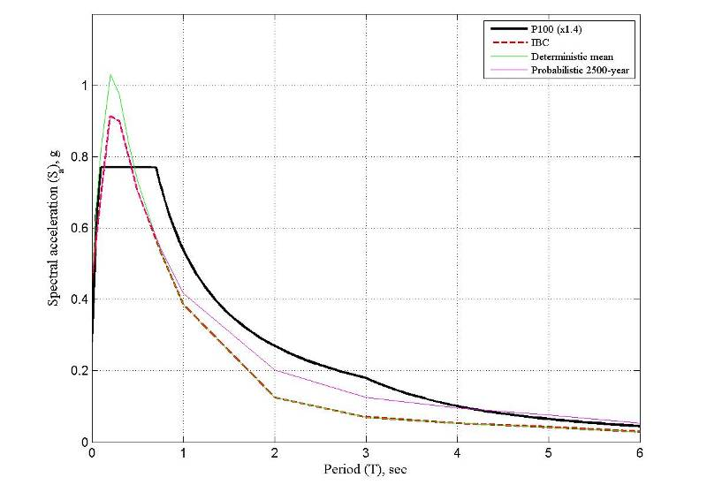

1. Comparison of the Romanian and IBC design spectra

Analytical model

General model properties

A three-dimensional analytical model of the building has been prepared using the program ETABS (CSI 2010); see . The key features of the model are summarized here.

* Material properties. Nominal properties were used for the existing and added elements. All walls and beams were modelled using the cracked sectional properties.
* Wall elements. All dimensions were specified as centreline-to-centreline. Contribution from the wall out of plane stiffness was neglected.
* Seismic loading. The analysis and evaluation was based on the response spectrum loading and load combinations developed and verified with nonlinear response history analyses.
* Isolators and sliders. These elements were modelled using “link” elements. Sample values were selected for analysis. Only the linear link properties are activated for the linear response spectrum analysis.
* 300 Ritz modes were used in analysis to ensure all links were activated and that the prominent building modes (isolated and otherwise) were captured.

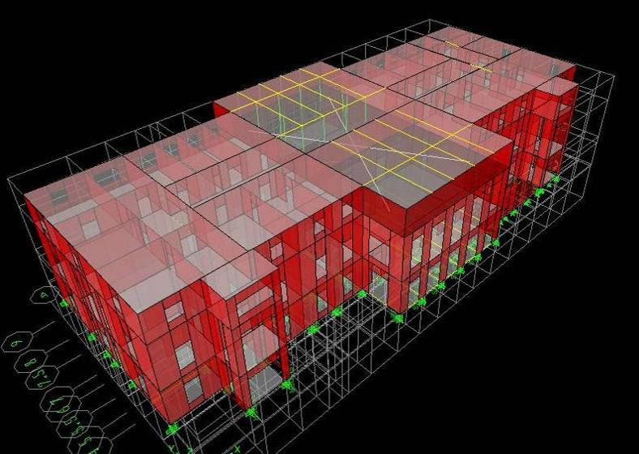

1. Analytical model of the building

Loading and load combinations

The dead load (inertial weight) of the building is comprised of the self-weight of all permanent structural and non-structural components of the building, including the new concrete slab and the added concrete beams at the isolation level. The total seismic mass of the structure is estimated at 16,800 Mg. Live loads are based on Romanian design code, *Basis of structural design in construction*, CR 0-2005. Per P100 (2007) the directional combinations for seismic loading, and the load combinations of , were used in design

Analysis results

presents the modal properties from the preliminary analysis of the isolated building. It is noted that approximately 95% of seismic mass in each direction participate in the isolated modes, and that the isolated modes have periods of approximately 2.5 to 2.7 sec.

|  |  |  |  |  |  |  |  |  |  |
| --- | --- | --- | --- | --- | --- | --- | --- | --- | --- |
| Dead | Live | Seismic load,  x- | Seismic load,  y- |  | Mode | Period, sec | Participating mass, % | | |
| 1.1 | 0.5 | +/-1.0 | +/- 0.3 |  | x- | y- | - |
| 1.1 | 0.5 | +/- 0.3 | +/-1.0 |  | 1 | 2.70 | 7 | 50 | 32 |
| 0.9 | 0.0 | +/-1.0 | +/- 0.3 |  | 2 | 2.64 | 86 | 9 | 0 |
| 0.9 | 0.0 | +/- 0.3 | +/-1.0 |  | 3 | 2.52 | 3 | 36 | 64 |
| 1. Design load combinations | | | |  | 1. Modal properties | | | | |

Figure 6 presents the computed displacement profile of the building from the response spectrum analysis. It is noted that the displacement is almost entirely concentrated at the isolation level, and drift ratios above and below the isolation plane are in the order of 0.02% or less. As such, the response is essentially rigid motion, with predominant elastic behaviour above the isolation plane. Figure 6 presents the computed story shear profile of the building from response spectrum analysis (normalized with respect to the building weight). It is noted that the maximum “base” shear coefficient just above the isolation plane is approximately 0.15g, thus satisfying the design objective.

|  |  |
| --- | --- |
|  |  |
| 1. Story displacement distribution | 1. Story shear distribution |

1. Story responses computed from response spectrum analysis

Retrofit design assessment

presents a comparison of pertinent response quantities computed from response spectrum analysis and target values. It is noted that the design meets the target requirements and, hence, is satisfactory.

|  |  |  |  |
| --- | --- | --- | --- |
| Response | Target value | Analysis value | Pass/Fail |
| Isolator displacement, mm | 450 | 300 | Pass |
| Story drift ratio | 0.5% | 0.02% | Pass |
| Base shear coefficient, g | 0.18 | 0.15 | Pass |
| Story shear, g | 0.15 | 0.15 | Pass |

1. Design criteria evaluation

Existing member and component evaluation

Overview

The existing unreinforced masonry (URM) walls were evaluated for rocking, shear, and toe-crushing strength at unreduced design spectrum demands using ASCE 41 criteria. Relevant masonry design parameters considered in our evaluation are listed in Table 4.

|  |  |
| --- | --- |
| Response | Target value |
| Knowledge (*k*) factor, | 0.75 |
| Condition of masonry | Good |
| Lower bound compressive strength | 6200 kPa |
| Lower bound shear strength | 180 kPa |
| Expected strength multiplier | 1.3 |
| Component demand modification (*m*) factor | 1.0 |

1. Design criteria checks

In order to assess the building’s overall performance, several representative wall lines were selected for detailed evaluation based on their location and tributary loading.

Demand calculations

ETABS was used to determine the load distribution in the building. Lateral loads considered in our design were based on the unreduced design spectrum (x 1.4).

Capacity calculations

The equations in ASCE 41 were used to determine the limiting failure for each pier, whether it be rocking or shear (the minimum of the wall shear and toe-crushing from shear). For the case where shear mode controls, one or more piers reach its shear capacity prior to its rocking capacity. Where piers within a wall line are excessively slender and have correspondingly low rocking capacity, they are omitted from the analysis, and the lateral load from the omitted piers is redistributed to the remaining piers. If the capacity is less than the actual shear in the pier, then the existing wall is satisfactory. For the case where rocking mode controls, the rocking capacity is less than the shear capacity for all piers. If the sum of the rocking pier capacities is greater than the shear along the wall line, then the existing wall line is satisfactory.

Results

The existing URM walls were found to be adequate for the unreduced design spectrum loading. Considering an m-factor of unity was used, all walls are expected to remain in the elastic range.

New member design

New concrete beams are required to support the existing walls, transfer load to the isolators, and redistribute to the existing foundations in a uniform pattern. Beams above the plane of isolation are used to capture the walls with both bearing and clamping force using post-tensioned high strength rods. During the initial stages of the isolator installation, the beams support the loads above by bridging across holes cut into the walls at each isolator location. After installation of the isolator, the remaining walls between the isolators are cut in order to complete the isolation, at which time the upper beams spans between the isolators in order to transfer the loads from above to the isolators. Beams below the plane of isolation are used to distribute the loads from the isolators uniformly to the continuous foundations below. These new beams also widen the bearing area of the existing foundations, providing enhanced bearing capacity. Additional beams were provided at isolators, perpendicular to the bearing walls above and below the plane of isolation, where necessary to provide resistance to P-Delta moments generated during the design seismic event.

New concrete slabs at the ground floor level were designed to span between bearing walls for both gravity loads as well as seismic diaphragm shear loads. New concrete slabs-on-grade are provided below the plane of isolation in order to provide in-plane continuity between walls for seismic loads as well as out-of-plane restraint for retained earth at the building perimeter and basement walls.

The retaining walls at the perimeter of the building and basement stairs are designed as cantilevered walls, restrained from sliding by the new concrete structure at the base of the isolation plane

Verification response history studies

Overview

Nonlinear response history analysis was conducted to verify the results obtained from the response spectrum analysis. The analysis used three strong motion records from previous Romania earthquakes, and analysis was based on the data obtained from the record producing the maximum response.

Analysis ground motions

Three pairs of ground motion, one each from 1977 (Station Incerc), 1986 (Station Iasi), and 1990 (Station Iasi) Vrancea earthquakes were used as seeds for analysis. These motions were selected to be representative of motions expected at the site. The motions were then spectrum matched to the P100 spectrum of Figure 4 and used in analysis. Two component motions for each record were developed. presents one of the pairs of matched records used in analysis.

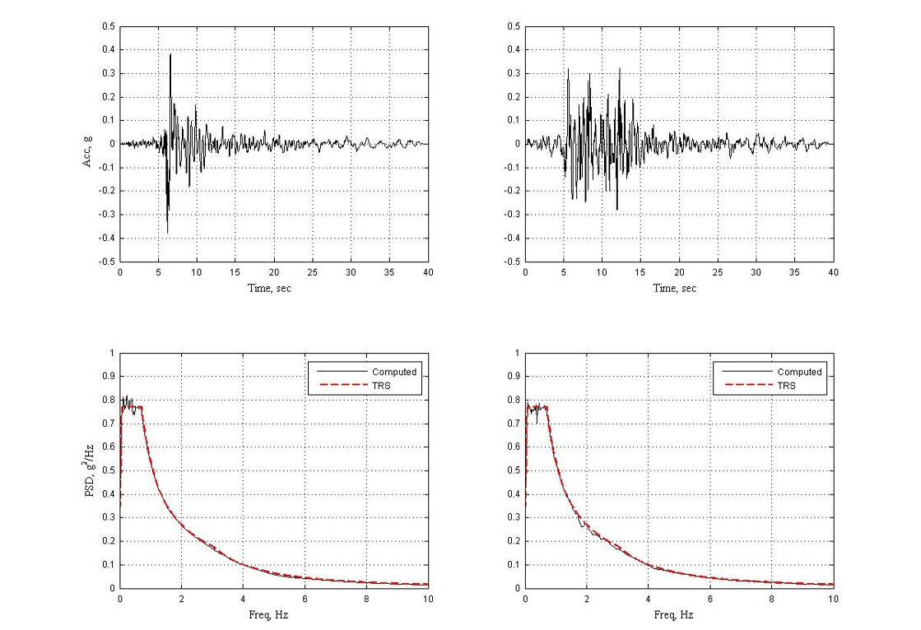

1. A pair of spectrum-matched records used in analysis

Analysis results

The nearest adjacent building to Iasi City Hall occurs at the S-W corner near Gridlines P and 3, with a separation of approximately 1000 mm. To allow for the motion of the isolated structure, a moat with a width of 300 mm (12 in) is provided around the building perimeter. Figure 8a presents the computed vectorial (SRSS) displacement at the subject corner. It is noted that the maximum computed displacement is well below 300 mm. Figure 8b presents the x- and y-component response of the normalized base shear for one response history analysis (the solid line). The dashed line corresponds to a base shear coefficient of 0.15. It is noted that the computed base shear for the isolated structure is less than 0.15g. The maximum computed horizontal acceleration at the roof level is approximately 0.15g.

|  |  |
| --- | --- |
|  |  |
| 1. Displacement response | 1. Normalized base shear |

1. Response history analysis results

Figure 9 presents the response of a typical LRB and metallic (friction) slider from the analysis. It is noted that both components dissipate a significant amount of energy.

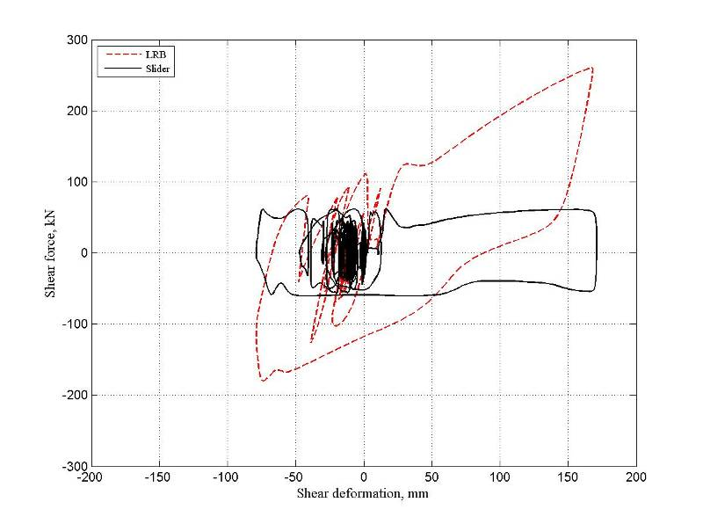

1. Response of isolation system

Conclusions

The historic Iasi City Hall is constructed of nonductile components. It has suffered damage in past earthquakes and does not meet the current Romanian seismic code requirements. The structure will be retrofitted with an isolation system comprised of LRB and sliders and was analyzed using response spectrum analyses.

* Analysis showed that the retrofit including the addition of the isolation system will significantly reduce the building base shear. The computed base shears, accelerations, and displacements were all within the target values.
* After retrofit, the seismic demand on the existing wall members would be significantly reduced and the unreduced demand on the walls was reduced below member capacities
* Response history analysis using three spectrum-compatible pairs of records selected from the Romanian (and Iasi) strong motion record database showed that the response of the isolated structure was satisfactory, and that the response spectrum analysis results used for design and evaluation of components envelope those obtained from time history analyses and are, therefore, appropriate for use in design.

References

ACI 318-05, *Building Code Requirements for Structural Concrete*, American Concrete Institute, Farmington Hills, MI.

ASCE/SEI 41-06 (2006), *Seismic Rehabilitation of Existing Buildings*, American Society of Civil Engineers, Reston, VA.

CR 0-2005, Design Code. *Basis of structural design in construction*, Romania.

CSI (2010), *ETABS:* *Linear and nonlinear static and dynamic analysis and design of building systems*, Computers and Structures, Inc., Berkeley, CA.

Geotechnical Survey (2007) “Refurbishing and Consolidation of the Town Hall Premises” by S.C. “Project-Lopis” S.R.L., Iasi.

IBC (2006), *International Building Code* (IBC), International Code Council, Whittier, CA.

Miyamoto, K. and Gilani, A. (2007), *Hazard risk mitigation and emergency preparedness: A comprehensive review*, Proceedings of the International Symposium on Seismic Risk Reduction, Bucharest, Romania.

P100/2003 *Code for the Seismic Designing of Constructions*, Construction Technical University of Bucharest, Romania.

Author Biographies

H. Kit Miyamoto, Ph.D., S.E.: President and CEO of Miyamoto International, Inc. Dr. Miyamoto is a registered structural engineer in several states in the US and has been in charge of seismic design and retrofit of a significant number of buildings. Dr Miyamoto has extensive experience in the design of structures with isolation and damping systems.

Amir S.J. Gilani, Ph.D., S.E.: Senior Associates at Miyamoto International, Inc. Dr. Gilani is a registered structural engineer in California and has extensive experience in seismic analysis and retrofit of structures. Dr. Gilani has extensive experience in analysis and design of structures with isolation systems.

Lon M. Determan, S.E.: Principal at Miyamoto International, Inc. Mr. Determan is a registered Structural Engineer in California with extensive experience in seismic retrofit design and historic preservation of buildings utilizing supplemental damping, isolation, and new technologies in the US and abroad.

1. President, Miyamoto International, Inc., Sacramento, CA, USA, KMiyamoto@miyamotointernational.com
2. Senior Associate, Miyamoto International, Inc., Sacramento, CA, USA, AGilani@miyamotointernational.com
3. Principal, Miyamoto International, Inc., Sacramento, CA, USA, LDeterman@miyamotointernational.com